Mobina Naseri

Lung-EffNet: Lung cancer classification using EfficientNet from CT-scan images

Abstract

Lung cancer, also known as lung carcinoma, is a malignant [tumor](https://en.wikipedia.org/wiki/Tumor) that begins in the [lung](https://en.wikipedia.org/wiki/Lung).

A person suspected of having lung cancer will have imaging tests done to evaluate the presence, extent, and location of tumors. First, many [primary care providers](https://en.wikipedia.org/wiki/Primary_care_provider) perform a [chest X-ray](https://en.wikipedia.org/wiki/Chest_X-ray) to look for a mass inside the lung. The X-ray may reveal an obvious mass, the widening of the [mediastinum](https://en.wikipedia.org/wiki/Mediastinum) (suggestive of spread to [lymph nodes](https://en.wikipedia.org/wiki/Lymph_node) there), [atelectasis](https://en.wikipedia.org/wiki/Atelectasis) (lung collapse), consolidation ([pneumonia](https://en.wikipedia.org/wiki/Pneumonia)), or [pleural effusion](https://en.wikipedia.org/wiki/Pleural_effusion); however, some lung tumors are not visible by X-ray. Next, many undergo [computed tomography (CT) scanning](https://en.wikipedia.org/wiki/CT_scan), which can reveal the sizes and locations of tumors.

The developed model Lung-EffNet attained 99.10% of accuracy and a score of 0.97 to 0.99 of ROC on the test set. We compared the efficacy of the proposed fine-tuned pre-trained EfficientNet with other pre-trained CNN architectures. The predicted outcomes demonstrate that EfficientNetB1 based Lung-EffNet outperforms other CNNs in terms of both accuracy and efficiency.

Keywords: Lung Cancer, Computed tomography, Deep learning, Medical imaging

1.Introduction

Cancer is a group of diseases involving [abnormal cell growth](https://en.wikipedia.org/wiki/Cell_growth#Disorders) with the potential to [invade](https://en.wikipedia.org/wiki/Invasion_(cancer)) or [spread](https://en.wikipedia.org/wiki/Metastasis) to other parts of the body. These contrast with [benign tumors](https://en.wikipedia.org/wiki/Benign_tumor), which do not spread. Possible [signs and symptoms](https://en.wikipedia.org/wiki/Signs_and_symptoms_of_cancer) include a lump, abnormal bleeding, prolonged cough, unexplained weight loss, and a change in [bowel movements](https://en.wikipedia.org/wiki/Defecation). While these symptoms may indicate cancer, they can also have other causes. Over [100 types](https://en.wikipedia.org/wiki/List_of_cancer_types) of cancers affect humans.Lung cancer, also known as lung carcinoma, is a malignant [tumor](https://en.wikipedia.org/wiki/Tumor) that begins in the [lung](https://en.wikipedia.org/wiki/Lung). Lung cancer is caused by [genetic damage](https://en.wikipedia.org/wiki/Genetic_damage) to the [DNA](https://en.wikipedia.org/wiki/DNA) of [cells](https://en.wikipedia.org/wiki/Cell_(biology)) in the airways, often caused by [cigarette smoking](https://en.wikipedia.org/wiki/Cigarette_smoking) or inhaling damaging chemicals. Damaged airway cells gain the ability to multiply unchecked, causing the growth of a tumor. Without treatment, tumors spread throughout the lung, damaging lung function. Eventually lung tumors [metastasize](https://en.wikipedia.org/wiki/Metastasize), spreading to other parts of the body.

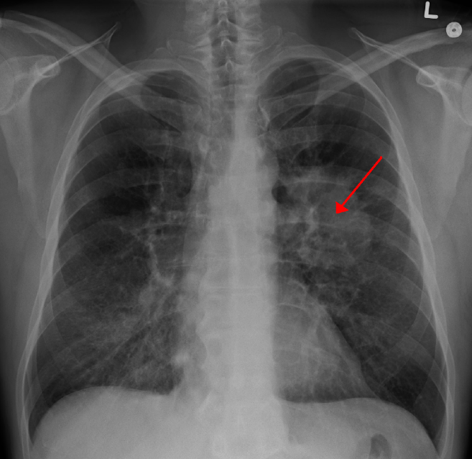

Fig 1. A [chest X-ray](https://en.wikipedia.org/wiki/Chest_X-ray) showing a tumor in the lung (marked by arrow)

Reference : https://en.wikipedia.org/wiki/File:LungCACXR.PNG

Early lung cancer often has no symptoms and can only be detected by [medical imaging](https://en.wikipedia.org/wiki/Medical_imaging). As the cancer progresses, most people experience nonspecific respiratory problems: [coughing](https://en.wikipedia.org/wiki/Coughing), [shortness of breath](https://en.wikipedia.org/wiki/Shortness_of_breath), or [chest pain](https://en.wikipedia.org/wiki/Chest_pain). Other symptoms depend on the location and size of the tumor. Those suspected of having lung cancer typically undergo a series of imaging tests to determine the location and extent of any tumors. Definitive diagnosis of lung cancer requires a [biopsy](https://en.wikipedia.org/wiki/Biopsy) of the suspected tumor be examined by a [pathologist](https://en.wikipedia.org/wiki/Pathologist) under a [microscope](https://en.wikipedia.org/wiki/Microscope). In addition to recognizing cancerous cells, a pathologist can classify the tumor according to the type of cells it originates from. Around 15% of cases are [small-cell lung cancer](https://en.wikipedia.org/wiki/Small-cell_lung_cancer) (SCLC), and the remaining 85% (the [non-small-cell lung cancers](https://en.wikipedia.org/wiki/Non-small-cell_lung_cancer) or NSCLC) are [adenocarcinomas](https://en.wikipedia.org/wiki/Adenocarcinoma), [squamous-cell carcinomas](https://en.wikipedia.org/wiki/Squamous-cell_carcinoma), and [large-cell carcinomas](https://en.wikipedia.org/wiki/Large-cell_carcinoma). After diagnosis, further imaging and biopsies are done to determine the cancer's [stage](https://en.wikipedia.org/wiki/Cancer_staging) based on how far it has spread.

Treatment for early stage lung cancer includes [surgery](https://en.wikipedia.org/wiki/Surgery) to remove the tumor, sometimes followed by [radiation therapy](https://en.wikipedia.org/wiki/Radiation_therapy) and [chemotherapy](https://en.wikipedia.org/wiki/Chemotherapy) to kill any remaining cancer cells. Later stage cancer is treated with radiation therapy and chemotherapy alongside drug treatments that target specific cancer subtypes. Even with treatment, only around 20% of people survive five years on from their diagnosis. Survival rates are higher in those diagnosed at an earlier stage, diagnosed at a younger age, and in women compared to men.

Most lung cancer cases are caused by [tobacco smoking](https://en.wikipedia.org/wiki/Tobacco_smoking). The remainder are caused by exposure to hazardous substances like [asbestos](https://en.wikipedia.org/wiki/Asbestos) and [radon](https://en.wikipedia.org/wiki/Radon) gas, or by [genetic mutations](https://en.wikipedia.org/wiki/Genetic_mutation) that arise by chance. Consequently, lung cancer prevention efforts encourage people to avoid hazardous chemicals and quit smoking. Quitting smoking both reduces one's chance of developing lung cancer and improves treatment outcomes in those already diagnosed with lung cancer.

Lung cancer is the most diagnosed and deadliest cancer worldwide, with 2.2 million cases in 2020 resulting in 1.8 million deaths. Lung cancer is rare in those younger than 40; the average age at diagnosis is 70 years, and the average age at death 72. Incidence and outcomes vary widely across the world, depending on patterns of tobacco use. Prior to the advent of cigarette smoking in the 20th century, lung cancer was a rare disease. In the 1950s and 1960s, increasing evidence linked lung cancer and tobacco use, culminating in declarations by most large national health bodies discouraging tobacco use.

Pulmonary nodule disease is an allergic disease of unknown cause with pathological manifestations of non-cheesy meat. Granuloma can invade organs and tissues of the whole body, and the organs commonly involved are lymph nodes, lungs, liver, spleen and skin, etc. The high incidence of pulmonary nodule lesions occurs in people aged 10-40 years, and the peak incidence occurs in people aged 20-30 years, and there is a gender difference, and it is more common in women. The identification of pulmonary nodule characteristics is of auxiliary significance for early screening of lung cancer and has positive significance for improving the survival time of lung cancer patients. According to the nature of pulmonary nodular lesions. It can be divided into benign and malignant nodules, and the treatment methods of different nodule properties vary greatly, so it is of great significance to clarify the nature of nodules. Wang Wei et al. pointed out that due to the small diameter of pulmonary nodules, routine examination is not of high diagnostic value, which is prone to misdiagnosis and missed diagnosis, causing delay in early treatment of the disease and affecting the quality of life of patients. Ches X-ray and sputum cytology have been commonly used in clinical diagnosis of pulmonary nodules, but the diagnostic effect is not good through large sample screening. With the development of multi-slice spiral CT post-processing technology, CT examination has been gradually used by clinicians to assist the diagnosis of pulmonary nodules. It has been reported abroad that CT examination can quickly demarcate abnormal areas, accurately identify benign and malignant nodules, measure the volume of nodules and observe the shape of nodules. Due to the limitation of thickness and scanning speed, CT plain scan is not effective in the early diagnosis of lung cancer. 16-row low-dose CT scan is of high value in the detection of small pulmonary nodules, which can quickly perform a wide range of scanning and multi-plane thin-layer reconstruction, and clearly show the small pulmonary nodules. However, there are relatively few such reports in China, so in this paper, spiral CT and 3D reconstruction are used in the diagnosis of pulmonary nodules and their application value is observed.

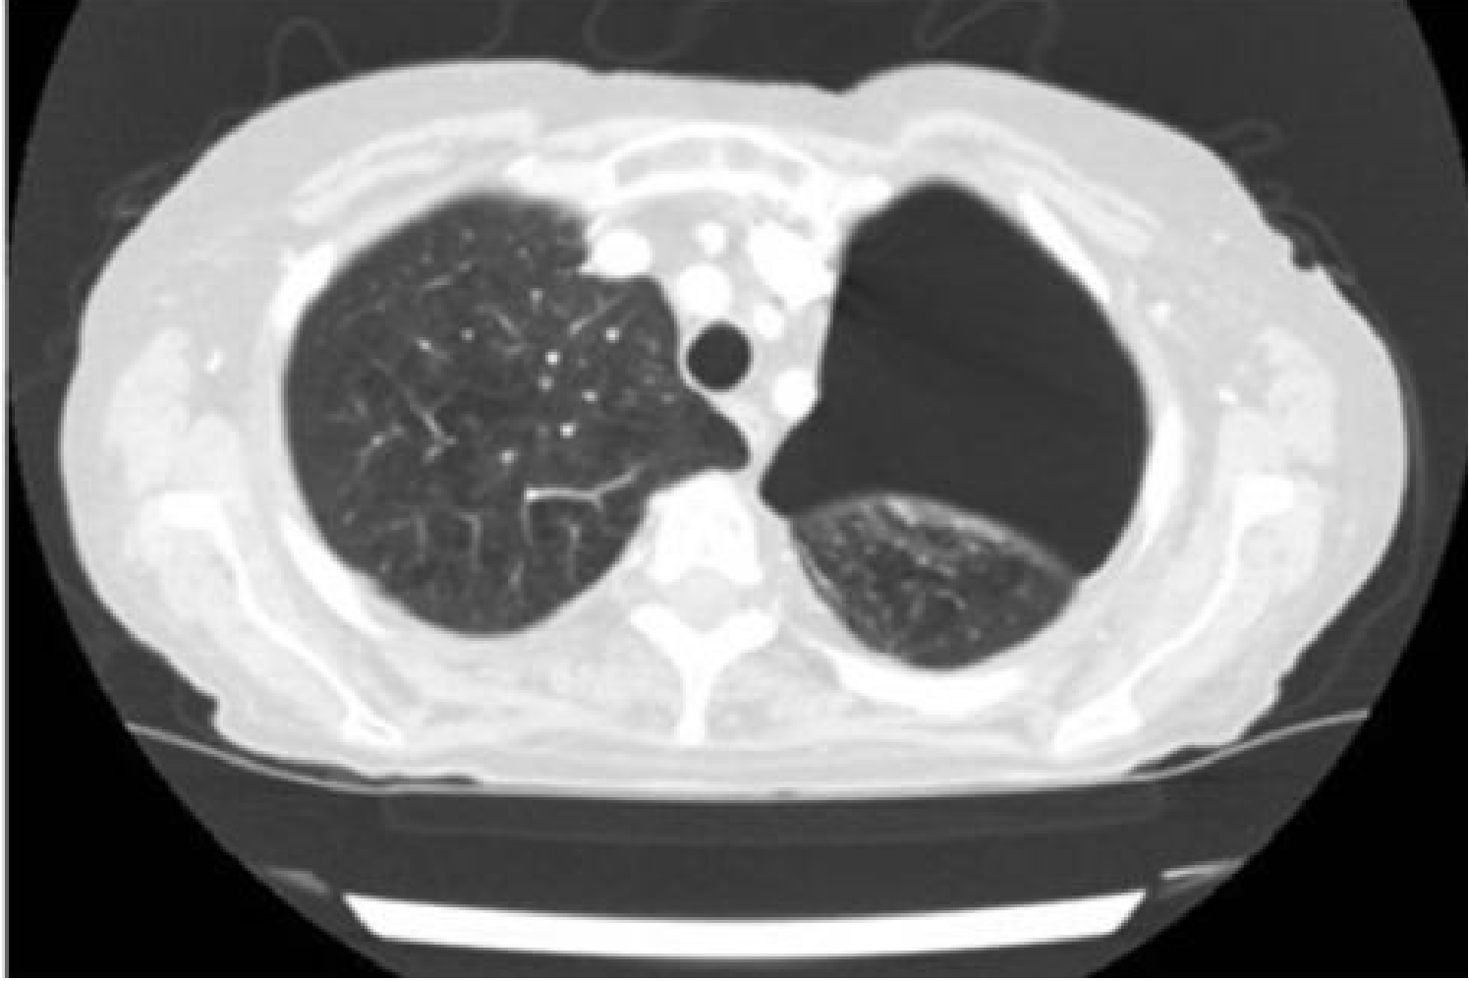

Fig 2. Lung window on a chest CT

Reference: Application analysis of ai technology combined with spiral CT scanning in early lung cancer screen

Diagnosis

A person suspected of having lung cancer will have imaging tests done to evaluate the presence, extent, and location of tumors. First, many [primary care providers](https://en.wikipedia.org/wiki/Primary_care_provider) perform a [chest X-ray](https://en.wikipedia.org/wiki/Chest_X-ray) to look for a mass inside the lung. The X-ray may reveal an obvious mass, the widening of the [mediastinum](https://en.wikipedia.org/wiki/Mediastinum) (suggestive of spread to [lymph nodes](https://en.wikipedia.org/wiki/Lymph_node) there), [atelectasis](https://en.wikipedia.org/wiki/Atelectasis) (lung collapse), consolidation ([pneumonia](https://en.wikipedia.org/wiki/Pneumonia)), or [pleural effusion](https://en.wikipedia.org/wiki/Pleural_effusion); however, some lung tumors are not visible by X-ray. Next, many undergo [computed tomography (CT) scanning](https://en.wikipedia.org/wiki/CT_scan), which can reveal the sizes and locations of tumors.

A definitive diagnosis of lung cancer requires a [biopsy](https://en.wikipedia.org/wiki/Biopsy) of the suspected tissue be [histologically](https://en.wikipedia.org/wiki/Histopathology) examined for cancer cells. Given the location of lung cancer tumors, biopsies can often be obtained by minimally invasive techniques: a fiberoptic [bronchoscope](https://en.wikipedia.org/wiki/Bronchoscopy) that can retrieve tissue (sometimes guided by [endobronchial ultrasound](https://en.wikipedia.org/wiki/Endobronchial_ultrasound)), [fine needle aspiration](https://en.wikipedia.org/wiki/Fine_needle_aspiration), or other imaging-guided biopsy through the skin. Those who cannot undergo a typical biopsy procedure may instead have a [liquid biopsy](https://en.wikipedia.org/wiki/Liquid_biopsy) taken (that is, a sample of some body fluid) which may contain [circulating tumor DNA](https://en.wikipedia.org/wiki/Circulating_tumor_DNA) that can be detected.

Imaging is also used to assess the extent of cancer spread. [Positron emission tomography](https://en.wikipedia.org/wiki/Positron_emission_tomography) (PET) scanning or combined [PET-CT](https://en.wikipedia.org/wiki/PET-CT) scanning is often used to locate metastases in the body. Since PET scanning is less sensitive in the brain, the [National Comprehensive Cancer Network](https://en.wikipedia.org/wiki/National_Comprehensive_Cancer_Network) recommends [magnetic resonance imaging](https://en.wikipedia.org/wiki/Magnetic_resonance_imaging) (MRI) – or CT where MRI is unavailable – to scan the brain for metastases in those with NSCLC and large tumors, or tumors that have spread to the nearby lymph nodes. When imaging suggests the tumor has spread, the suspected metastasis is often biopsied to confirm that it is cancerous. Lung cancer most commonly metastasizes to the brain, bones, liver, and [adrenal glands](https://en.wikipedia.org/wiki/Adrenal_gland). Lung cancer can often appear as a [solitary pulmonary nodule](https://en.wikipedia.org/wiki/Solitary_pulmonary_nodule) on a chest radiograph or CT scan. In lung cancer screening studies as many as 30% of those screened have a lung nodule, the majority of which turn out to be benign. Besides lung cancer many other diseases can also give this appearance, including [hamartomas](https://en.wikipedia.org/wiki/Hamartoma), and infectious [granulomas](https://en.wikipedia.org/wiki/Granuloma) caused by [tuberculosis](https://en.wikipedia.org/wiki/Tuberculosis), [histoplasmosis](https://en.wikipedia.org/wiki/Histoplasmosis), or [coccidioidomycosis](https://en.wikipedia.org/wiki/Coccidioidomycosis).

CT scan

A computed tomography scan (CT scan; formerly called computed axial tomography scan or CAT scan) is a [medical imaging](https://en.wikipedia.org/wiki/Medical_imaging) technique used to obtain detailed internal images of the body. The personnel that perform CT scans are called [radiographers](https://en.wikipedia.org/wiki/Radiographer) or radiology technologists.

CT scanners use a rotating [X-ray tube](https://en.wikipedia.org/wiki/X-ray_tube) and a row of detectors placed in a [gantry](https://en.wikipedia.org/wiki/Gantry_(medical)) to measure X-ray [attenuations](https://en.wikipedia.org/wiki/Attenuation#Radiography) by different tissues inside the body. The multiple [X-ray](https://en.wikipedia.org/wiki/X-ray) measurements taken from different angles are then processed on a computer using [tomographic reconstruction](https://en.wikipedia.org/wiki/Tomographic_reconstruction) algorithms to produce [tomographic](https://en.wikipedia.org/wiki/Tomography) (cross-sectional) images (virtual "slices") of a body. CT scans can be used in patients with metallic implants or pacemakers, for whom [magnetic resonance imaging](https://en.wikipedia.org/wiki/Magnetic_resonance_imaging) (MRI) is [contraindicated](https://en.wikipedia.org/wiki/Contraindication). Since its development in the 1970s, CT scanning has proven to be a versatile imaging technique. While CT is most prominently used in [medical diagnosis](https://en.wikipedia.org/wiki/Medical_diagnosis), it can also be used to form images of non-living objects. The 1979 [Nobel Prize in Physiology or Medicine](https://en.wikipedia.org/wiki/Nobel_Prize_in_Physiology_or_Medicine) was awarded jointly to

South African-American physicist [Allan MacLeod Cormack](https://en.wikipedia.org/wiki/Allan_MacLeod_Cormack) and British electrical engineer [Godfrey Hounsfield](https://en.wikipedia.org/wiki/Godfrey_Hounsfield) "for the development of computer-assisted tomography".

Fig 3. Trends in Cancer Survivorship in India and Globally.

Reference: Unifed deep learning models for enhanced lung cancer prediction with ResNet-50–101 and EfcientNet-B3 using DICOM images

Medical image analysis using deep learning techniques has the potential to enhance the overall robustness, performance, and efficiency of LC classification (Sun et al., 2016). Transfer learning has emerged as a valuable technique in the field of lung cancer detection and classification, as evidenced by several studies. The study by Wang et al. (2020) focuses on the classification of different pathological types of lung cancer using CT images. They employ a transfer learning strategy with deep residual neural networks (ResNets) to achieve accurate classification results. By leveraging pre-trained models and fine-tuning them on a specific lung cancer dataset, the authors demonstrate the effectiveness of transfer learning in improving classification performance. In another study by Sajja et al. deep transfer learning is employed for lung cancer detection based on CT scan images. By utilizing pre-trained models and adapting them to the task of lung cancer detection, the researchers achieve promising results. This highlights the importance of transfer learning in leveraging pre-existing knowledge from related tasks to improve lung cancer detection accuracy. Katsamenis et al. (2020) explore the application of transfer learning in COVID-19 pneumonia detection and classification using chest X-ray images. Transfer learning is also utilized for the differential diagnosis of lung cancer using conventional CT and FDG PET/CT images. The study showed that transfer learning, combined with metadata, can enhance the performance of deep learning systems in distinguishing between benign and malignant lung lesions (Chen. This highlights the importance of transfer learning in leveraging existing knowledge to improve the accuracy of a lung cancer diagnosis. Furthermore, Protonotarios et al. propose a few-shot U-Net deep learning model for lung cancer lesion segmentation via PET/CT imaging. They employ transfer learning to leverage pre-trained models and adapt them to the task of segmenting lung cancer lesions. This demonstrates the significance of transfer learning in enhancing the efficiency and accuracy of lung cancer lesion segmentation, a critical step in diagnosis and treatment planning. Collectively, the aforementioned studies emphasize the importance of transfer learning in the domain of lung cancer detection, classification, and segmentation. By leveraging pre-trained models and fine-tuning them on specific lung cancer datasets, transfer learning enables the utilization of existing knowledge and significantly improves the accuracy and performance of deep learning models. This approach proves valuable in enhancing the understanding and diagnosis of lung cancer, ultimately leading to more effective treatment strategies and improved patient outcomes. The primary objective of this study is to ascertain the presence of cancerous cells in lung nodule CT-scan images. To achieve this, the research focuses on classifying lung cancer into three distinct categories: Benign, Malignant, and Normal, based on CT-scan slices of lung nodules. To accomplish this classification task, transfer learning is employed using five variants of pre-trained EfficientNet models, specifically EfficientNet B0 to B4. Each variant of the EfficientNet model is fine-tuned explicitly on CT-scan slices of lung cancer. Fine-tuning involves adapting the pre-trained models to the specific characteristics and features of the lung cancer dataset, allowing them to capture relevant patterns and information. During the fine-tuning process, the feature maps generated by the EfficientNet models are extracted. These feature maps represent high-level representations of the input CT-scan slices, capturing important spatial and semantic information. These extracted feature maps are then passed through fully connected layers, which are responsible for performing the classification task. The fully connected layers analyze the extracted features and make predictions regarding the presence of Benign, Malignant, or Normal lung cancer. By employing this transfer learning approach and leveraging the capabilities of the EfficientNet models, the study aims to achieve accurate and reliable classification results for lung cancer based on CT-scan slices of lung nodules. Transfer learning with EfficientNets can offer several advantages that may help address common limitations in the field of medical image analysis. EfficientNets are known for their ability to extract meaningful and representative features from images. By leveraging transfer learning, the pre-trained EfficientNet models can capture relevant features from large-scale datasets (e.g., ImageNet) and transfer this knowledge to the task of lung cancer segmentation. This can potentially improve the accuracy and robustness of the segmentation process. Additionally, EfficientNets have demonstrated their effectiveness in various computer vision tasks, including object recognition and segmentation. By fine-tuning these models on medical image datasets, such as lung cancer images, the network can learn to generalize well to the specific characteristics and variations present in medical images, contributing to improved segmentation performance. Moreover, EfficientNets are designed to achieve a good balance between model size and performance. They have shown superior efficiency in terms of computational resources and memory requirements compared to other deep learning architectures.

2.Research background

Over the past decade, multimodal data collection has led to significant growth in the medical field. Deep learning, which is based on artificial neural systems, is an advanced machine learning strategy with the potential to transform the fake insights industry, as it is known. DL offers a range of organized types with different capabilities, allowing professionals to take care of a large amount of restorative information, including literature data, audio signals, restorative images and recordings. These DL systems, moreover, known as models, have been shown to be profoundly viable devices in various restorative contexts. Both ML and DL models have achieved success in various fields of medicine, including prevention, cancer diagnosis, and diagnosis of COVID-19 and medical data analysis. DL models play a prominent role in medicine, with the selection and configuration of networks depending on the specific field, data volume, and research goals. For a comprehensive list of commonly used DL networks and their distinguishing features in the medical industry, see Table 2. Machine learning and deep learning are gradually being used in therapeutic research, and cancer prevention and detection could be key areas of focus. In addition, it shows that lung cancer is more concentrated compared to breast cancer. This study shows that the proportion of breast and lung cancer is the highest. These facts were collected by Google Scholar at noon on October 24. Table 3 shows that previous research has been flawed, with some studies showing poor accuracy due to the use of incorrect methods or parameters. Some researches used complex models, but most researches only used one or two indicators, which is not enough to evaluate accuracy and effectiveness. To achieve high performance with low computational representation, the representation thinker considers off-the-job learning preferences, exchange learning, and specific deep models with computational efficiency.

Fig 4. Trends in deep learning cancer research mortality, 2012–2023

Reference: Unifed deep learning models for enhanced lung cancer prediction with ResNet-50–101 and EfcientNet-B3 using DICOM images

3. Material and methods

In this section, the data set used and the method adopted to train the proposed model for the classification of multi-level lung cancer from CT scan will be explained. I load slices of CT scan images into the collection at the beginning of this procedure. Several pre-processing steps are then applied to the uploaded images. Since our main problem is based on medical imaging due to the large volume of medical images, therefore, it is difficult to collect a large amount of data to train our proposed model. Consequently, data augmentation is used to artificially expand the number of training samples.

3.1. Dataset

The experiments are carried out on the “Iraq-Oncology Teaching Hospital/National Center for Cancer Diseases (IQ-OTH/NCCD)” lung cancer dataset (. In 2019, the dataset was collected from the “Iraq-Oncology Teaching Hospital and National Center for Cancer Diseases” for more than three months. The dataset consists of CT scans of patients who are either healthy or diagnosed with different stages of lung cancer. The dataset was annotated by multiple oncologists and radiologists. The dataset consists of a total of 1097 images of a human chest representing CT scan slices of 110 cases varying in age, gender, education status, residence, and living status. The cases in this study were divided into three categories: benign, malignant, and normal, as depicted in Fig. 2. A total of 110 cases were analyzed, with 40 being identified as malignant, 15 as benign, and 55 as normal. The CT scans used in the study were initially obtained in DICOM format, with a resolution of 512 × 512, but were later converted to JPEG for ease of access. The IQ-OTH/NCCD dataset is publicly available in the Kaggle repository. The breakdown of the dataset by class-wise category is presented in Table 1.

3.2. Data preprocessing

This section discusses the pre-processing steps applied to the dataset before training and testing the model. All the images of each class and classification are first mixed together for training and checking, and then they are divided into a test ratio of 80:20 so that we use 80% of all images for sampling training. While only 20% are used in the training set for sampling.

Because medical images and CT scan images have unwanted noises and problems. They may cause errors in the tutorial, so we cut the images.

The classification and distribution of the class after the test is shown in Table 2.

After the images are cropped, data augmentation is applied to the cropped images. The images in the train and test set are then resized to a fixed resolution of 240 × 240 × 3 to match the shape of the input tensor to the required input shape of the pre-trained EfficientNet models. Image resizing also helps reduce computational overhead during model training by preserving textual information and features of an image. Finally, the class labels in both train and test sets are coded as 0, 1, and 2 for benign, malignant, and normal, respectively.

3.3. The main working method

In this part, we will perform the main method of implementing images using EfficientNetB1 and explain the steps

3.4.1. Data training transfer

Contrary to conventional methods of machine learning and artificial intelligence, CNN or the cognitive neural network enables the automatic extraction of low-level and high-level feature maps from the convolutional base layers, integration and batch normalization of the model.

The one-dimensional extracted feature vector created from these extracted feature maps is then sent to a set of monomorphic or single or multiple fully connected layers for classification. Despite its huge success, one of the drawbacks of CNN is that it requires a lot of data samples to effectively and usefully train the model and avoid problems with bias (overfitting) and high variance (overfitting). to provide us with the best results.

However, it is not practical to collect a significant amount of annotated data for various research challenges, especially in the field of medical imaging. Due to the large amount of data and images and noises and problems that may exist in these images for us.

Moreover, much of the data is not even available for free. Transfer learning technique can be used to overcome the above issue.

Transfer learning transfers knowledge derived from architectures initially trained on larger benchmark datasets such as ImageNet to problems such as classifying lungs as either similar or different from their original tissue. Cancer from CT scan slices with fewer data points.

None of the pre-trained CNN schemes can be directly used for inference.

To adapt to the images in the target domain, the layers of the pre-trained models are experimentally refined and checked. Instead, to match the images in the target domain, layers of pre-trained models are empirically good. The fine-tuning technique involves retraining the weights taken from several layers above the deep CNN architecture for different specific problems. These weights were initially trained on a very large dataset. By freezing all or some layers in convolutional base layers or by using pre-trained architectures as fixed feature extractors that are then fed to other classifiers such as SVM for classification, architectures Pre-trained can be well adjusted.

3.4.2. Classification using fine-tuned EfficientNet

The deep CNN-based architectures are usually ove parameterized, due to the increasing number of convolutional layers, network depth, and width as a result of which, the efficiency of the network is compromised and makes an architecture computationally expensive. There is a tradeoff between network efficiency and accuracy. Deep networks might generalize well on test data but their efficiency in terms of inference speed, floating-point operations per second (flops), network parameters, and model size increases. In 2019, the Google AI research team proposed a family of EfficientNet series, namely EfficientNetB0–EfficienNetB7 (Tan and Le, 2019), as a backbone architecture that has outperformed many state-of-the-art deep CNN-based architectures such as Inception-V3, ResNet50, Inception-ResNetV2, DenseNet for image classification from ImageNet, segmentation, and other transfer learning based problems. In contrast to conventional scaling methods utilized by previous studies in their proposed architecture, which include arbitrarily increasing network width, depth, and resolution to increase the generalizability of the network. The CNN architecture is structurally scaled up by the EfficientNet utilizing fixed sets of scaling coefficients using a uniform compound scaling approach. Compound scaling is based on the idea of balancing the dimension of depth d, width w, and resolution r of a network by scaling it with a constant ratio. Mathematically equation is given in (1).



so that α.β2.γ2≈2 where α ≥1, β ≥1, γ ≥1. The values ​​of α, β and γ are determined by a grid search algorithm. ∅ is a user-defined parameter that determines the increase in the computational resource of the network. The flops of the network convolution operation are directly proportional to d, w2 and r2, so that if the depth of the network doubles, the flops will double. On the other hand, if the width and resolution of the grid are doubled, the flops will be quadrupled. However, grid scaling according to Eq. (1), the increase in flops is according to the relation (α.β2.γ2)∅ such that for each new value of ∅, the total number of flops increases by 2∅. The entire EfficientNet architecture consists of a base block followed by 7 blocks and a final layer as shown in Figs.

Each block in EfficientNet has a variable number of modules, and as one progresses from EfficientNetB0 to EfficientNetB7, the number of modules increases. Each type of EfficientNet has variable depth and parameters. The simplest version of EfficientNet, EfficientNetB0, has 237 layers and 5.3 million parameters, while EfficientNetB7

It has 813 layers and 66 million parameters. The EfficientNet architecture uses Mobile Reverse Bottleneck Convolution (MBConv) layers just like MobileNetV2 and MnasNet. Since the normalization layer already exists in the base layer of EfficientNet, no additional image normalization is required as a pre-processing step, so it takes an input image with pixel intensity values ​​in the range of 0-255. In this research, five types of EfficientNet pre-trained namely EfficientNet B0-B4 are used as the backbone for lung cancer classification from CT scan slices. The criteria for selecting the best efficient network changes depend on several variables, including dataset size, available resources for model training and evaluation, model depth, network parameters, and batch size. EfficientNetB5 to EfficientNetB7 are larger variants of EfficientNet with deeper network and more parameters. Because of this, the model may overfit the training set and larger computing resources (GPU + RAM) are required to train the model. EfficientNetB0–EfficientNetB4 are exclusively used as the backbone for lung cancer classification for the reasons mentioned. This research involves transfer learning of five pre-trained EfficientNet variants, EfficientNetB0 to EfficientNetB4, which were initially trained on the ImageNet benchmark dataset. Lung cancer CT scan slices are specifically used to fine-tune these models. Figure 9 shows the modified EfficientNetB1 network architecture. First, the pre-trained EfficientNet is fine-tuned by initializing the base model with the ImageNet weights as the backbone. To reduce dimensionality, a global average (GAP) aggregation layer is placed on top of the EfficientNet backbone while keeping the weights constant in the convolutional basis of each block. Without affecting the model performance in terms of accuracy, the GAP layer also helps to simplify the network in terms of a number of parameters. An elimination layer with a probability of 0.5 is added to the network after the GAP layer. An adjuster called trackout helps prevent the model from overfitting. Since the dataset has three class labels, the initial output layer with 1000 units is replaced by an output layer with 3 units with Softmax activation layer. The entire architecture is retrained on the IQ-OTH/NCCD lung cancer dataset.

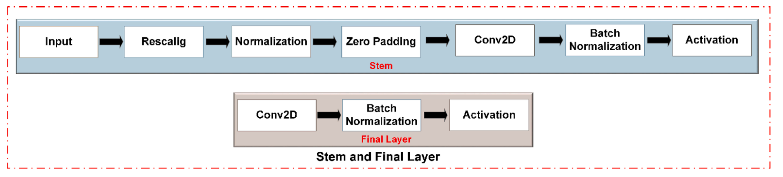

Fig 5. Stem and Final layer in EfficientNet.

REFERENCE: Lung-EffNet: Lung cancer classification using EfficientNet from CT-scan images

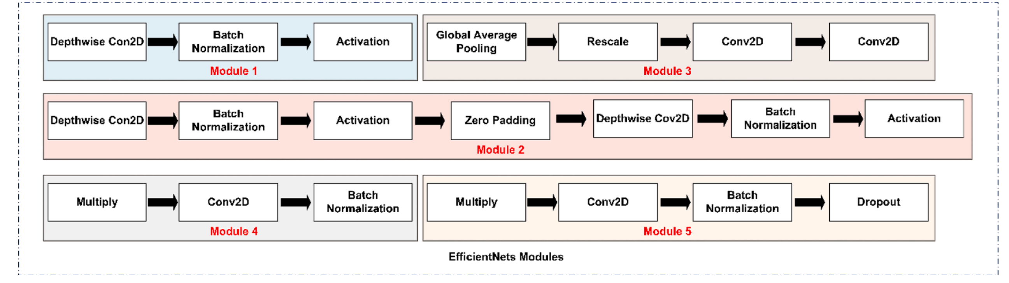

Fig 6. Five modules in EfficientNet. Each module has a different type of layer based on the nature of the required feature maps

REFERENCE: Lung-EffNet: Lung cancer classification using EfficientNet from CT-scan images

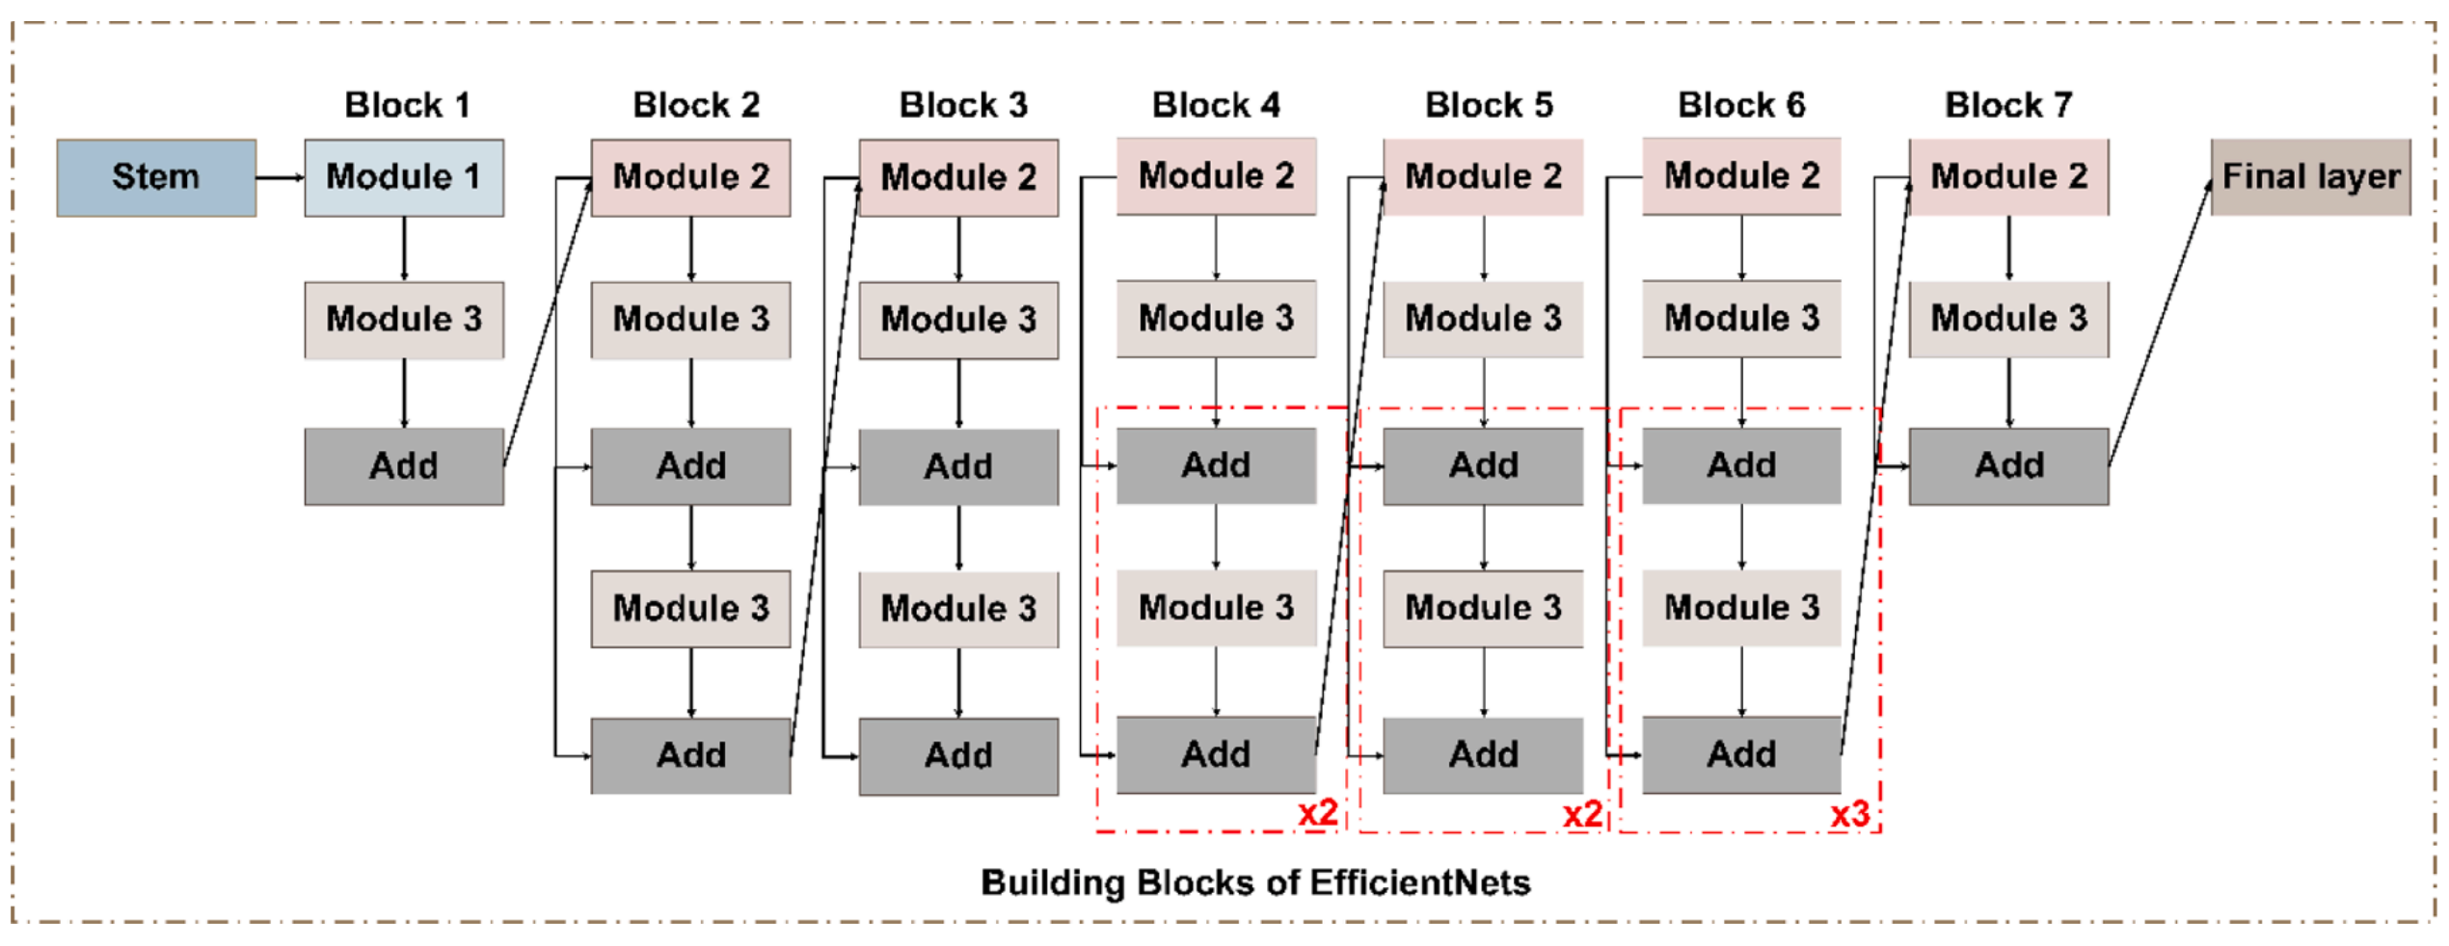

Fig 7. The general architecture of EfficientNetB1. Each EfficientNet has seven blocks with a variable number of modules in each block.

REFERENCE: Lung-EffNet: Lung cancer classification using EfficientNet from CT-scan images

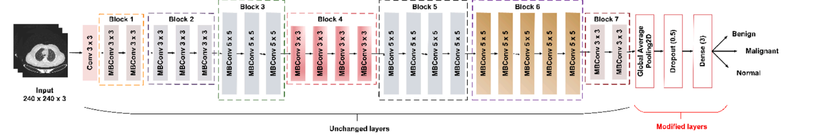

Fig 8. The proposed method of fine-tuning pre-trained EfficientNetB1. The classification layer of the pre-trained EfficientNet is modified by the addition of GAP, dropout, and output layers. The layers in each EfficientNet block are kept unchanged.

REFERENCE: Lung-EffNet: Lung cancer classification using EfficientNet from CT-scan images

4.Results

Figure  9 presents a comprehensive diagram of the lung cancer determination strategy, highlighting the key methods included. At first, the lung CT imaging dataset is obtained. Hence, the preparation, approval, and test sets experience an arrangement of image-processing procedures to guarantee compatibility with the deep learning organized input layer. These strategies incorporate RGB change and scaling into a 224*224 arrangement. To improve the preparation to prepare and empower the demonstration to memorize different levels of image corruption, in this manner anticipating overfitting and progressing the preparing to arrange, the preparing set is advance altered through information increase. Tis step includes turning, flipping, and zooming the lung CT image to create different forms of the same CT image. Vertical flipping, zooming, and turning are utilized as modifiers for image control. The three models, specifically ResNet-50, ResNet-101, and EfecientNetB3, are at that point prepared and approved utilizing these procedures. Tese models were chosen based on their adequacy in image classification errands, with EfecientNet-B3, ResNet-50, and ResNet-101 being prevalent profound demonstrate sorts as shown in Table  2. EfecientNet-B3 is considered a low-computation profound demonstration. To address the lung cancer conclusion issue, the exchange learning method is utilized to retrain the same pre-trained deep learning models. This includes consolidating extra layers into the insightful plan. The proposed deep learning models incorporates a crucial show, to be specific ResNet-50, ResNet-101, or EfcientNet-B3, taken after by a bunch normalization layer, a thick layer with 256 neurons, and ’ReLU’ enactment work, a dropout layer with a 35% dropout rate, and a classification layer with a ’Softmax’ enactment work and four neurons speaking to the targets. All models will be built utilizing the Adam optimizer with a learning rate of 0.01, as per the chosen preparation criteria. The connected misfortune work for this issue is the categorical cross-entropy because it could be a multi-class classification issue. The chosen execution metric is precision. The bunch estimate being utilized is 50. To decide when to end the preparing handle, a resistance level of 5 is set, meaning that if the watched degree does not move forward after 5 preparing emphasis, the method will halt. The degree being followed for this reason is the approval precision. Furthermore, the learning rate decrease figure is 0.5.  The input images size 224×224-pixel were used by the authors to train the first convolutional layers of the ResNet model with a stride of two. Using ReLU activation functions, nonlinearity is integrated into the network design. With these designs, the images provided need to be appropriately downscaled to enable the feature extraction. Using categorical cross-entropy as the loss function and accuracy as the selected performance indicator, the study takes use of multi-class classification. 50-person batches are trained, and the training is terminated when the validation precision does not increase above a tolerance level of five rounds. Convergence is improved during training by reducing the learning rate by a factor of 0.5. Each of the three transfer learning models (ResNet-50, ResNet-101, and EfcientNet-B3) uses a learning rate of 0.001 using the Adam-Optimizer while training the model to classify lung cancer by analysing CT scan images. It was found through the study of learning behaviour that ResNet-50 has a saturation at epoch 32, whereas ResNet-101 and EfcientNet-B3 may also have a saturation near epoch 32, depending on their convergence speed and complexity. Observing the learning rate saturation is vital for interpreting the training dynamics of the model and refining the training strategy. The demonstrated ResNet-50-Dense-Dropout experienced preparing with the preparing set and was assessed utilizing the assessment set. After this, the prepared show was surveyed utilizing the test set and assessment measurements. Additionally, the demonstrated ResNet-101-Dense-Dropout was prepared to utilize the preparation set and tried utilizing the assessment set. The prepared show was at that point assessed utilizing the test set and assessment measurements. The Efcient-B3-Dense-Dropout demonstration was moreover prepared to utilize the preparing set and tried utilizing the assessment set. The prepared show was at that point put to the test utilizing the test set and appraisal criteria. The three preparing models were combined at the score level, and the combined demonstration was evaluated. Also, a gathering was made utilizing the stacking outfit strategy, comprising the ResNet-50-Dense-Dropout, ResNet-101-DenseDropout, and Efcient-B3-Dense-Dropout models. The learned outfit demonstration was tried utilizing the test set and assessment measurement.

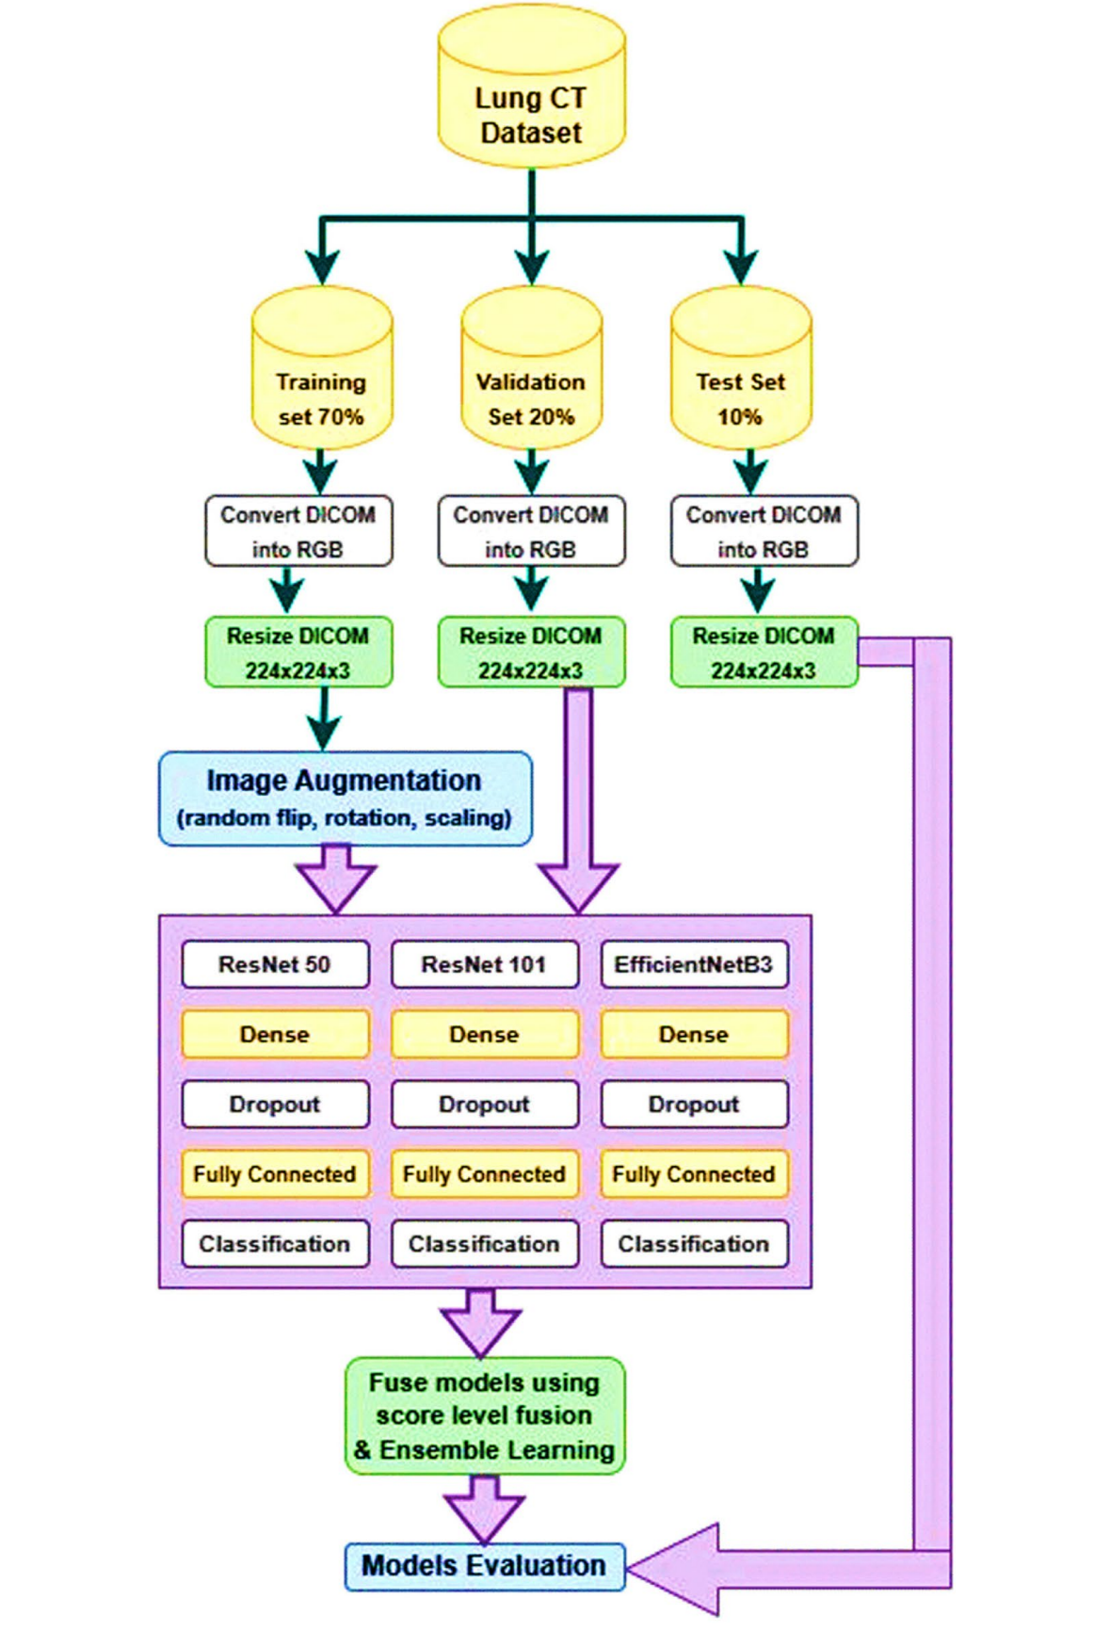

Fig 9. Fusion of three deep learning models for improved lung cancer diagnosis

REFERENCE: Unifed deep learning models for enhanced lung cancer prediction with ResNet-50–101 and EfcientNet-B3 using DICOM images

All models will be built utilizing the Adam optimizer with a learning rate of 0.01, as per the chosen preparation criteria. The connected misfortune work for this issue is the categorical cross-entropy because it could be a multi-class classification issue. The chosen execution metric is precision. The bunch estimate being utilized is 50. To decide when to end the preparing handle, a resistance level of 5 is set, meaning that if the watched degree does not move forward after 5 preparing emphasis, the method will halt. The degree being followed for this reason is the approval precision. Furthermore, the learning rate decrease figure is 0.5. The input images size 224×224-pixel were used by the authors to train the first convolutional layers of the ResNet model with a stride of two. Using ReLU activation functions, nonlinearity is integrated into the network design. With these designs, the images provided need to be appropriately downscaled to enable the feature extraction. Using categorical cross-entropy as the loss function and accuracy as the selected performance indicator, the study takes use of multi-class classification. 50-person batches are trained, and the training is terminated when the validation precision does not increase above a tolerance level of five rounds. Convergence is improved during training by reducing the learning rate by a factor of 0.5.Each of the three transfer learning models (ResNet-50, ResNet-101, and EfcientNet-B3) uses a learning rate of 0.001 using the Adam-Optimizer while training the model to classify lung cancer by analysing CT scan images. It was found through the study of learning behaviour that ResNet-50 has a saturation at epoch 32, whereas ResNet-101 and EfcientNet-B3 may also have a saturation near epoch 32, depending on their convergence speed and complexity. Observing the learning rate saturation is vital for interpreting the training dynamics of the model and refining the training strategy. The demonstrated ResNet-50-Dense-Dropout experienced preparing with the preparing set and was assessed utilizing the assessment set. After this, the prepared show was surveyed utilizing the test set and assessment measurements. Additionally, the demonstrated ResNet-101-Dense-Dropout was prepared to utilize the preparation set and tried utilizing the assessment set. The prepared show was at that point assessed utilizing the test set and assessment measurements. The Efcient-B3-Dense-Dropout demonstration was moreover prepared to utilize the preparing set and tried utilizing the assessment set. The prepared show was at that point put to the test utilizing the test set and appraisal criteria. The three preparing models were combined at the score level, and the combined demonstration was evaluated. Also, a gathering was made utilizing the stacking outfit strategy, comprising the ResNet-50-Dense-Dropout, ResNet-101-DenseDropout, and Efcient-B3-Dense-Dropout models. The learned outfit demonstration was tried utilizing the test set and assessment measurements.

Table 1. Hypermeters consideration

|  |  |  |  |
| --- | --- | --- | --- |
| Hyperparameter | ResNet-50 | ResNet-101 | EfcientNet-B3 |
| Input Image Size | 224×224 pixels | 224×224 pixels | 224×224 pixels |
| Kernel Sizes | 7×7, 1×1, 3×3, 5×5 | 7×7, 1×1, 3×3, 5×5 | NA |
| Stride (Initial Convolution) | 2 | 2 | NA |
| Stride (Subsequent Convolution) | 1 | 1 | NA |
| Activation Function | ReLu | ReLu | ReLu |
| Number of Layers | 50 | 101 | NA |
| Residual Blocks | YES | YES | NA |
| Global Avg Pooling | YES | YES | YES |
| Compound Scaling | NO | NO | YES |
| Squeeze-and-Excitation Blocks | NO | NO | YES |

5.discussion

Pulmonary nodular disease is a common lung disease. Recently, the incidence of pulmonary nodular disease is increasing. Pulmonary nodular lesions can be classified into benign and malignant lesions according to pathological properties. However, due to the small diameter of the nodules, most of which are less than 3cm, routine examination is of little value in distinguishing the nature of pulmonary nodules, and the probability of misdiagnosis and missed diagnosis is high. There is a great difference in the treatment of benign nodules and malignant nodules. Therefore, it is of great significance to find a method to accurately identify the nature of pulmonary nodules to formulate treatment plan and improve the outcome of the disease. CT is a common means of clinical diagnosis of pulmonary nodular lesions, which is convenient to operate, non-invasive to the body, fast scanning speed, and strong repeatability, so it is favored by clinicians and patients. Spiral CT is a commonly used diagnostic method for clinical diagnosis of pulmonary nodular lesions. The image and time resolution of this scan are both high, which can provide physicians with morphological information of nodules, help physicians observe the pathophysiology of nodules, and provide great help for clinicians in diagnosis. However, spiral CT plain scan cannot clearly show the direct relationship between bronchial arteries and some lesions, which is not conducive to pulmonary nodular diseases Become diagnosed. In the process of diagnosing small pulmonary nodules, low-dose CT scan can quickly scan the overlapping lesions of mediastinum and diaphragm, and perform high-resolution multi-plane reconstruction to obtain clear images of small pulmonary nodules. As a new imaging method, 3D reconstruction technology is gradually used in clinical diagnosis of diseases. This technology can use software to post-process images and obtain clear

diseases. The stove image. SSD, MPR and VOI are the common methods of 3D reconstruction technology. The above methods can obtain the oblique plane of the section fault at any Angle by using the computer to reassemble any section. The image processed by 3D reconstruction technology has no artifacts, and the three-dimensional shape of the lesion and the spatial relationship between the lesion and neighboring tissues can be clearly observed, which is conducive to doctors to make accurate diagnosis. In summary, 3D reconstruction technology after multi-slice spiral CT image has certain application value in the diagnosis of benign and malignant pulmonary nodules of fox elevation, but there is still a high rate of missed diagnosis. Parallel test using CT plain scan and 3D reconstruction technology can greatly improve the sensitivity and consistency of clinical diagnosis and has good clinical application value. However, the sample size of the included cases in this study is small and the selection is limited, so it is necessary to increase the sample size and conduct more in-depth research in the future.

6.Conclusion and future scope

In conclusion, this study examined the use of deep learning models for precise lung cancer diagnosis and classification, including ResNet-50, ResNet-101, and EfcientNet-B3. Extensive analysis of experimental data and cross-validation with prior research demonstrated the eficacy of the proposed Fusion Model, particularly in accurately diagnosing Squamous Cell Carcinoma. The remarkable 92% increase in prediction accuracy of the combined model demonstrates how revolutionary it may be for the identification and management of lung cancer. These findings highlight the potential of deep learning algorithms to offer tailored treatment regimens and ultimately reduce the mortality rate from lung cancer. To enhance patient outcomes and advance medical imaging capabilities, forthcoming endeavours ought to concentrate on refining model architectures, broadening datasets, and encouraging multidisciplinary partnerships. In the future, deep learning models can be used in a wide range of research projects and using larger datasets. Additionally, it was noted that obtaining knowledge and achieving certain scores was connected to improving health and lowering lung cancer death rates by dealing with the problem of inaccurate precision.

REFERENCE

1: Lung-EffNet: Lung cancer classification using EfficientNet from CT-scan images

2: Application analysis of ai technology combined with spiral CT scanning in early lung cancer screening

3: Unifed deep learning models for enhanced lung cancer prediction with ResNet-50–101 and EfcientNet-B3 using DICOM images